Notice

## Semester 1 – Exam Results

F.Y. B.Sc. Home Science Students who appeared for First semester exams in October/November 2018 can check their results online. Follow the steps mentioned below to check your first semester results.

1. Visit college website (<http://svt.edu.in/>). Scroll down to “**Student Notices**” Section.

2. Click on the link mentioned in the “**Student Notices**” section. (<http://bit.ly/SVTResults>).

3. You should be able to see below mentioned screen when you open the link. Enter you 1st semester seat number & click on Get Results.

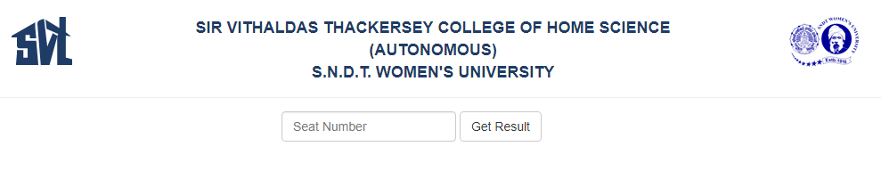 **Notes:**

1. Make sure you enter correct seat number mentioned in your hall tickets.
2. Do not enter spaces in between your seat number.
3. The results are available for only First Semester Regular students. Semester 3 & Semester 5 results are yet to be declared.

Please contact Examination cell in case of any queries.

Date – December 18, 2018

Controller of Examination